**ISCG7424 Mobile Software Development**

**Group Project - Checkpoint 2**

**Team Members:**

Rikin Shah -1486371

Ji Xu -1485142

You Yujia -1468225

Cheng Yuhao -1452709

**Product Name** : Quiz King

**Product Type** : Mobile Application

**Runtime** : Android Studio

**Technologies**

* Java
* Phonegap
* Appcelerator
* Telerik
* Marvel
* Invision
* Sketch Paper
* Firebase database
* Android studio

**Layout**

Sign Up Page. This page contains information about sign in to the account and create a new account.

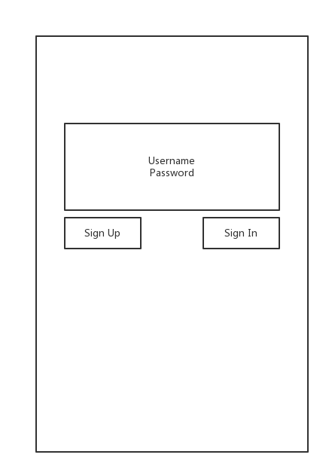

Main Page. This page contains information about didferent quizs in system.

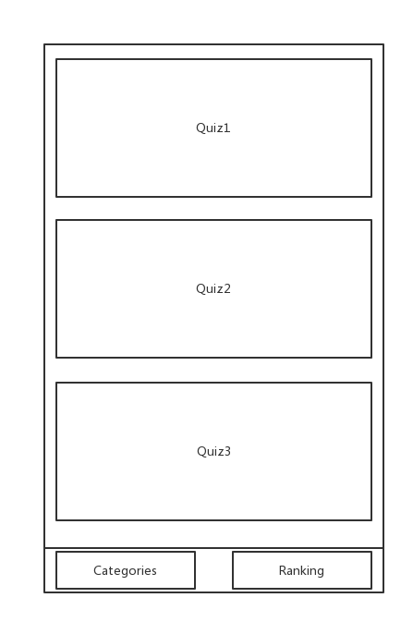

Quiz Page. This page contains examination questions and the potential answers.

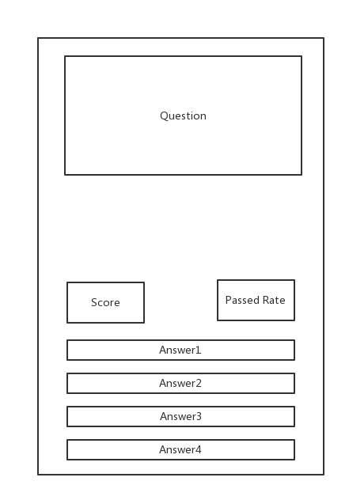

**Database**

We are using Firebase database to manage users’ information, including email address, password, and username.

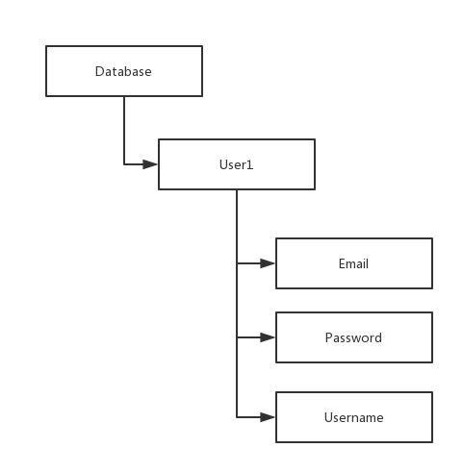

# Work plan

|  |  |
| --- | --- |
| Task | Responsibility |
| Planning, Research |  |
| Idea brainstorm | All team |
| Market research | jixu |
| Cost research | Rikin Shah |
| Development time need | Yuhao cheng |
|  |  |
| Design |  |
| User interface design | youyujia |
| Prototype | Rikin Shah |
| Functionality design | All team |
|  |  |
| Implementation |  |
| Function implement | All team |
|  |  |
| Testing |  |
| User interface testing | Yuhao cheng |
| Functionality testing | jixu |

**Risk Assessment Plan**

**Key technical:**

MVC, Google map API, Yahoo weather API, Spring, Restful API.

**Risks:**

NETWORK has Interception of data over the air. Mitigation: We should use same server and network in the same location.

TECHNICALS are unfamiliar that need to be self-study.Mitigation: This should be considered in the preparation.

HARDWARE may damage in the development. Mitigation: We should keep integrating and making backups everyday.

INTEGRATION AND COORDINATION efficiency. Mitigation: need sufficient time to integration and meet two times a week.

TEAM MANAGEMENT efficiency. Mitigation: use Agile development method and environment.